（参考如何选材写文章，以及关键字是如何在文章首段，正文，末端中自然加入的，红色标注为关键字）

2013 Spring Women Dresses Trends Forecast
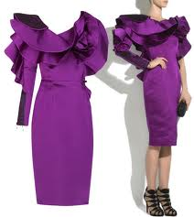
2013 Spring Women Dresses Trends Forecast: For the season of Spring 2013, there are quite a few fashion trends for you to follow in this season. One of the major factors in women swear is “the New Female Figure”, which means that women begin to seek new ways to appear more feminine apart from the traditional dresses and light clothes that are common for spring or summer. The representative trend is ruffles.
Ruffles can create a softer and more delicate look for you wherever they appear. Nowadays, more emphasis is put on sex and women want to appear more feminine, so this spring designers focus on these factors to design the ruffles combined with fashion colors to meet this purpose.
There are diverse uses of ruffles in 2013 Spring Women Dresses Trends. They will be used to decorate dresses, trousers, skirts, bags, swimwear and even shoes to make those look trendy and flirty.
Here also has a list of other 2013 Spring Fashion Trends：Belted Floral Dresses, hemlines just above the knee to midi length Flapper-style Dresses — dropped waists, slip dresses; fringe and metallics Tropical Patterns — bold colors on everything from maxi dresses to jumpsuits Collarless Blouses Slash Neck Tees Boucle Suiting Cowgirl Boots — metallic leathers, reptile skin, cut-aways. If you are a fashionista, then hope you can get some inspiration from this 2013 Spring Women Dresses Trends Forecast.

